If you want to join the cours/meeting from your smartphone or tablet follow the

instructions below.

1. 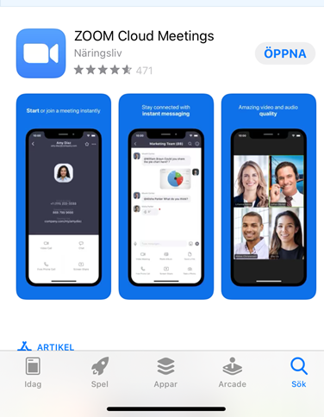**Download the app ZOOM**
2. **Click on *join meeting***   
     
   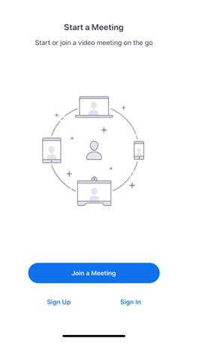
3. Under **Meeting ID** you add the number and you will get access to the meeting.

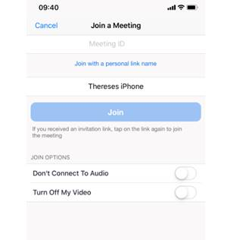

**Good luck and enjoy!** 